freETarget
Application Note: Ethernet Adapter

INTRODUCTION
FreeETarget supports a variety of different communications interfaces:
- USB
- WiFi
- RS485
- Token Ring
- Ethernet
This document describes adding an Ethernet adapter to the target. This allows the user to route all of the targets into a robust network that can be easily accessed anywhere on the range.

REQUIRED EQUIPMENT
The following items are required.
- FreeETarget Version 5 or higher
- PUSR USR-TCP23-T2 available through a variety of suppliers.
- Cable Harness
- Ethernet cable, CAT 5 or higher
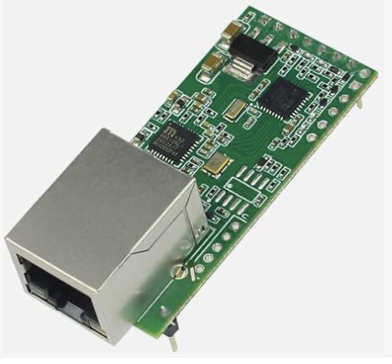

PREPARATION
- Build the cable harness as shown in Figure 1
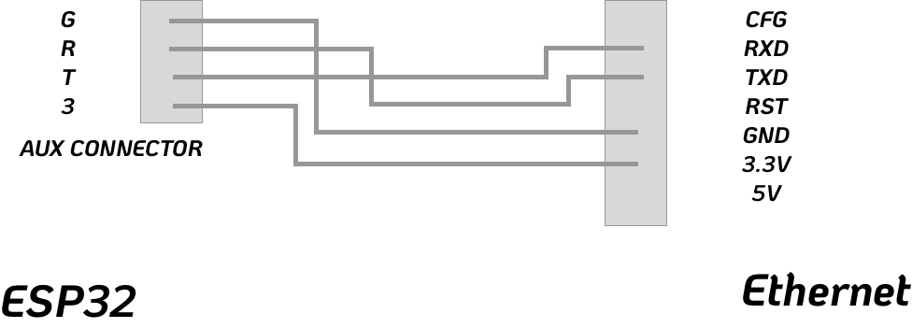
Figure 1: USB-TCP232-T2 Cable Harness
IMPORTANT
When using with Version 5 boards, connect the voltage signal (3 in Figure 1) to the 5VDC pin of the PUSA
- Power on the target.
- Configure the auxiliary interface to Ethernet {“AUX_MODE”:16}
- Connect the Ethernet cable to the adapter.
  - Verify that the green LED is illuminated, if not verify the cabling.

CONFIGURATION
The USR-TCP232-T2 can be configured using the built in web browser. Unfortunately, it is very particular about how this interface is accessed. Errors in the configuration may result in bricking the part and may be irretrievably broken with simple tools.
Building the Network
The Ethernet interface is delivered with IP address 192.168.0.7.
Connect the interface to the network, ensuring that there are no other devices on the network with that address. Make sure that your PC is also on a 192.168.0.x network.

Connecting to the Adapter
Open a web browser to 192.168.0.7. You will see the opening screen as shown in Figure 2
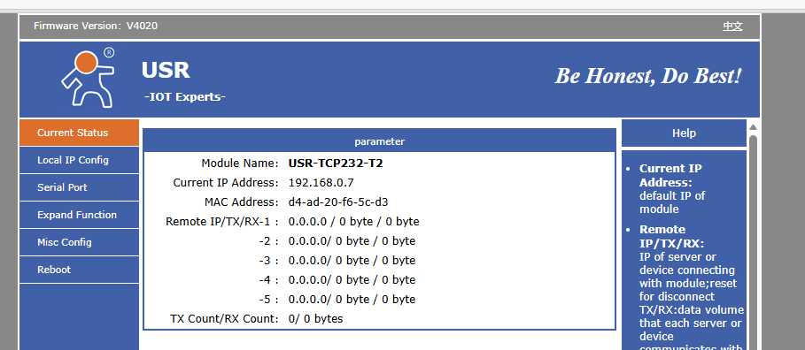
Figure 2: Opening Screen

Setting up the IP address
Manually change the IP address (Static IP) as shown in Figure 3 to the address you want on your network.
The IP address must be unique on that network.
The Gateway and DNS server entries are not used by the target and can be left alone.
Press SAVE
IMPORTANT Record the IP address in the worksheet. If you lose the IP address, there is almost no way to recover the device
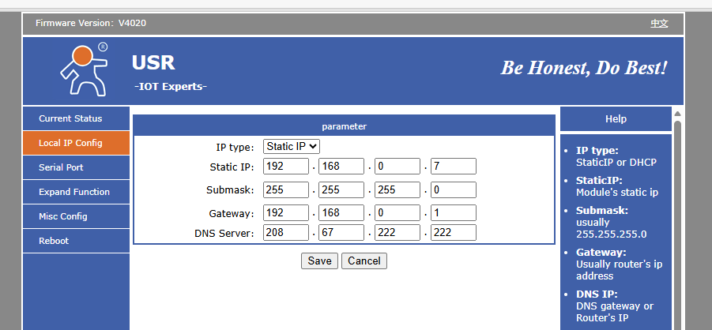
Figure 3: Setting the IP address

Setting up the Interface
Set the Work Mode to Server as shown in Figure 4.
The Local Port Number should be left alone but may be changed to 1090 if desired.
Record the port number in the worksheet.
Press SAVE
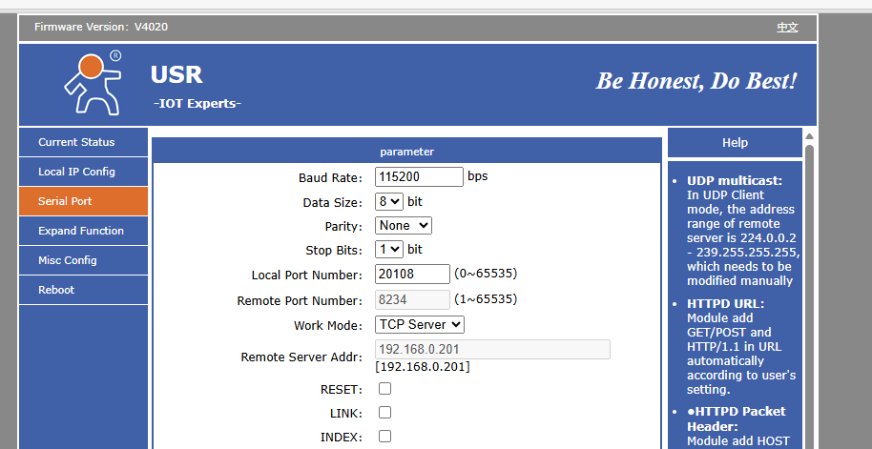
Figure 4: Serial Interface
Miscellaneous Configuration
Do not make any changes to the Miscellaneous Configuration shown in Figure 5
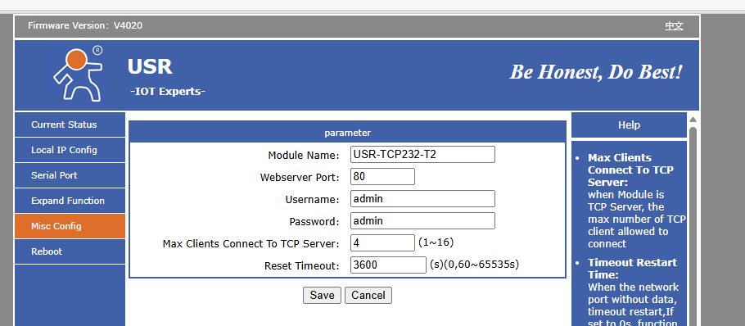
Figure 5: Miscellaneous Configuration

Restart the Adapter
Press the RESTART MODULE to reboot the adapter as shown in Figure 6.
After restarting, the adapter will change to the IP address recorded in the worksheet. The device can be changed by logging into the new address and making changes

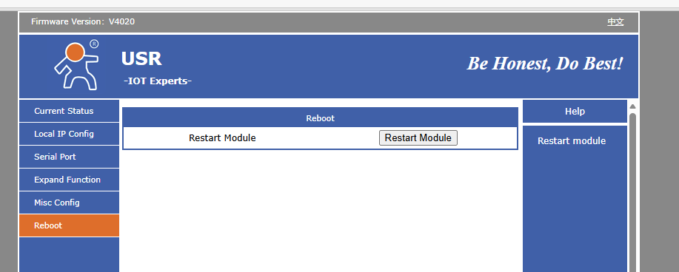
Figure 6: Restarting the Module

USING THE ETHERNET ADAPTER
Once the adapter reboots, it will come up as (for example) 192.168.0.7 and can be accessed as if the target was connected to WiFi.
Change the connection type in the FreeETarget configuration as shown in Figure 7
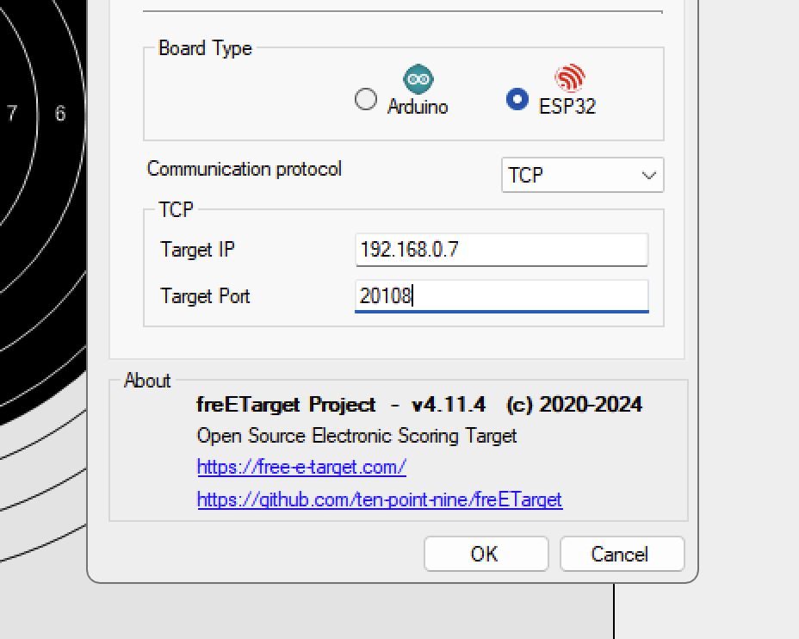
Figure 7: FreeETarget Configuration
The Ethernet Adapter will work with all versions of the PC Client.
Ethernet Work Sheet
Target Name | IP Address | Local Port Number
FET-TARGET | 192.168.0.7 | 20108

